Assignment 2.1 (IP Addressing)
Registration ID: 260640160209
PNR: 260740150018
Name: PRATIK SUNIL ABHANG

1. What is IP Addressing?
IP addressing is a system used to identify devices on a network. An IP address gives a device a logical address so that data can be sent from one device to another.
Just like a house needs an address to receive a letter, a device needs an IP address to communicate on a network.
Example: If a computer has the IP address 192.168.1.10, other devices on the same network can use this address to communicate with it.
- Identifies a device or network interface.
- Helps routers decide where packets should be sent.
- Makes communication possible between devices on the same or different networks.

2. What are the Different Versions of IP Addresses?
There are two major versions of Internet Protocol in use: IPv4 and IPv6.
Feature | IPv4 | IPv6
Full form | Internet Protocol version 4 | Internet Protocol version 6
Address size | 32 bits | 128 bits
Format | Dotted decimal | Hexadecimal, separated by colons
Example | 192.168.1.10 | 2001:db8::1
Number of addresses | About 4.3 billion total addresses | Extremely large address space
Main purpose | Traditional and still widely used IP addressing | Designed to provide a much larger address space and modern IP features

Important: IPv4 is still very common, while IPv6 is increasingly used because IPv4 addresses are limited.

3. Describe IPv4 in Detail

What is IPv4?
IPv4 stands for Internet Protocol version 4. It is the fourth version of the Internet Protocol and is one of the most widely used protocols for identifying devices and delivering packets across networks.

How is IPv4 Structured?
An IPv4 address is 32 bits long. These 32 bits are divided into four groups called octets. Each octet contains 8 bits and is written as a decimal number from 0 to 255.
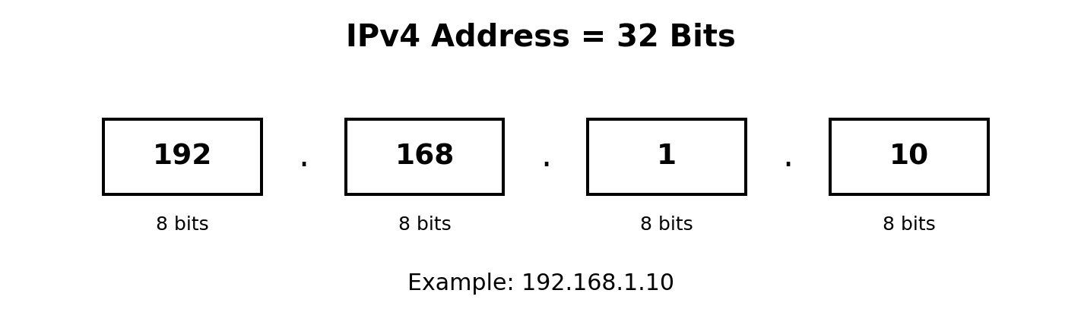
Part | Size | Possible Values
1st octet | 8 bits | 0–255
2nd octet | 8 bits | 0–255
3rd octet | 8 bits | 0–255
4th octet | 8 bits | 0–255
Total | 32 bits | 2³² possible combinations

Dotted decimal format: The four octets are separated by dots. Example: 192.168.1.10.
Binary example: 192.168.1.10 can be represented as 11000000.10101000.00000001.00001010.
Range: Each octet can have a value from 0 to 255 because 8 bits can represent 256 values (0 through 255).

4. Classes of IPv4 Addressing
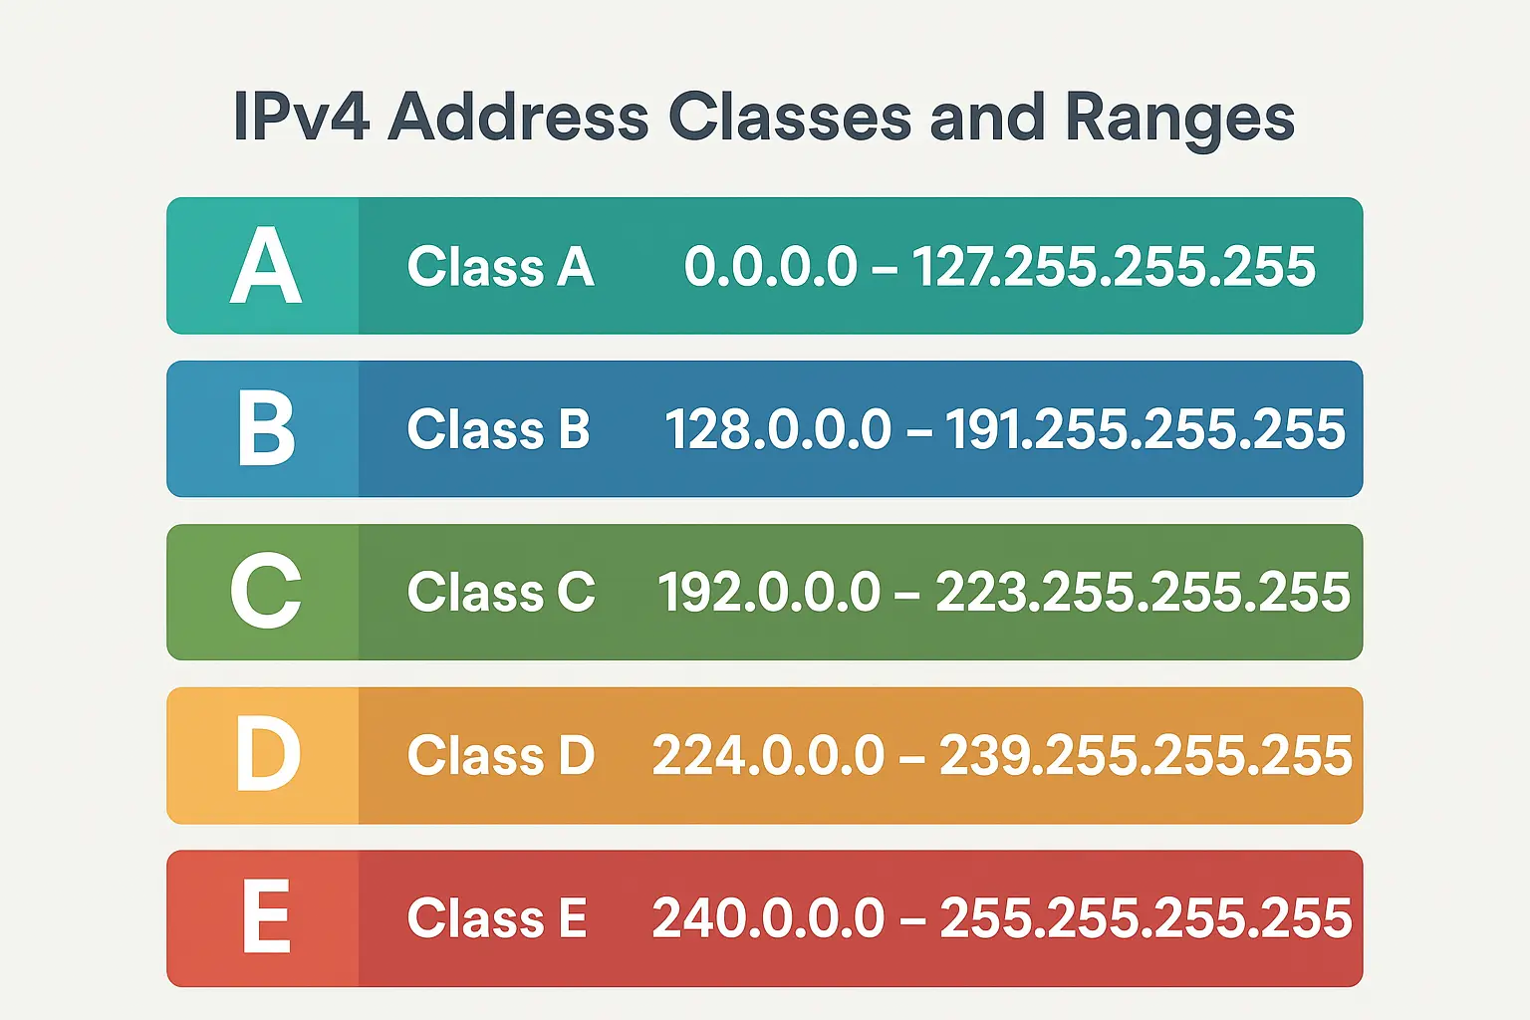
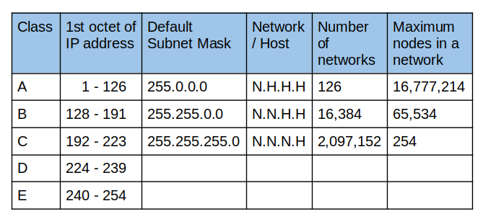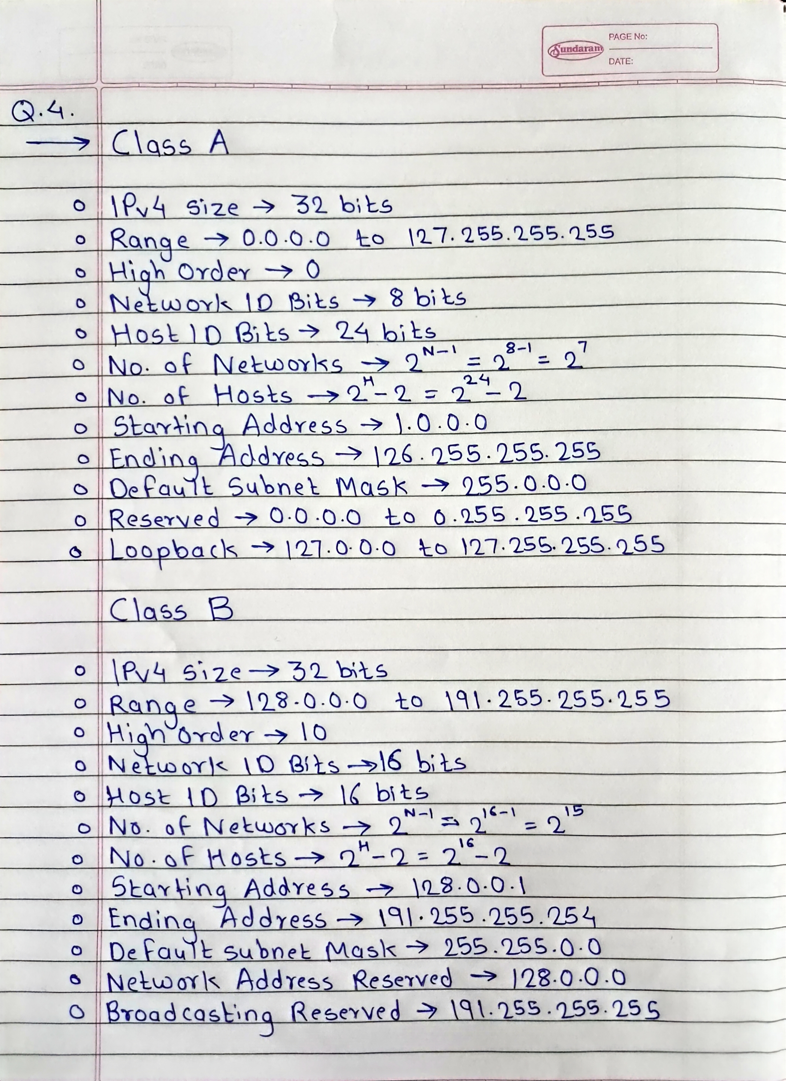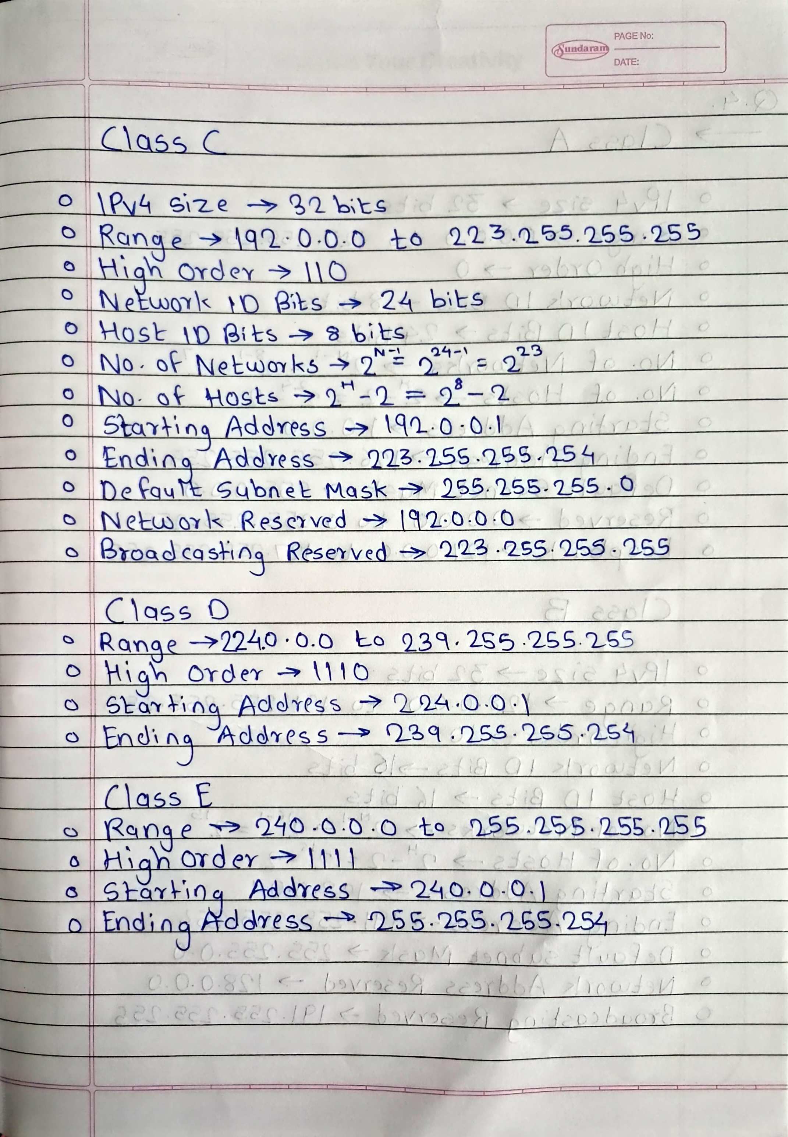

Assignment 2.2 (Broadcasting)
Registration ID: 260640160209
PNR: 260740150018
Name: PRATIK SUNIL ABHANG
1. What is Broadcasting?
Broadcasting is a communication method in a computer network in which data or messages are sent from one device to all devices within a specific network or broadcast domain. In broadcasting, the sender does not need to specify a particular receiver; all devices in the broadcast domain receive the broadcast message, although only the devices for which the message is relevant will process it. For example, an ARP request in an IPv4 local network is sent as a broadcast so that the device with the required IP address can respond.
2. Where is Broadcasting commonly used?
Broadcasting is commonly used in local area networks (LANs) for network discovery and communication. Common uses include:
• ARP (Address Resolution Protocol): An IPv4 host broadcasts an ARP request to find the MAC address associated with an IP address on the local network.
• DHCP (Dynamic Host Configuration Protocol): A client can broadcast a DHCP request when it does not yet have an IP address or know the DHCP server's address.
• Network and service discovery: Broadcast messages can be used to discover devices or services on a local network.
• Routing and network protocols: Some older or specific network protocols use broadcast messages to distribute information within a broadcast domain.
3. What are the drawbacks of Broadcasting?
• Unnecessary traffic: Every device in the broadcast domain receives the broadcast, even if the message is not relevant to it.
• Network congestion: A large number of broadcast messages can consume network bandwidth and reduce network performance.
• Limited scalability: Broadcast traffic becomes less efficient as the number of devices in a network increases.
• Processing overhead: Devices must receive and examine broadcast frames, which can waste CPU and network resources.
• Security concerns: Broadcast messages can expose information to all devices within the broadcast domain and may be misused in certain network attacks.

